2.

CREATE TABLE People (

ID int identity (1,1),

FirstName nvarchar (20),

ParentName nvarchar (20),

LastName nvarchar (20),

ID_Father int,

ID_Mother int

)

INSERT INTO [dbo].[People] (FirstName, ParentName, LastName, ID_Father, ID_Mother)

VALUES (N'Дмитрий', N'Евгеньевич', N'Иванов', 3, 1),

(N'Александр', N'Владимирович', N'Греков', 6, 2),

(N'Евгений', N'Алексеевич', N'Иванов', 7, 3),

(N'Руслан', N'Андреевич', N'Красовский', 8, 4)

SELECT * FROM [dbo].[People]

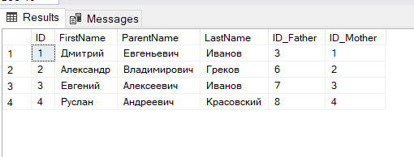

SELECT concat (a.[FirstName], ' ', a.[ParentName], ' ', a.[LastName]) as ФИО_son,

concat (b.[FirstName], ' ', b.[ParentName], ' ', b.[LastName]) as ФИО_father

FROM [People] a, People b

WHERE a.[FirstName] = N'Дмитрий'

AND a.[ID_Father] = b.[ID]

